CO2 AT1

Name: M Deepika
Reg: 192311027
Topic:Smart Energy Meter with Data Transmission Using SystemC
1. Aim
To construct and simulate a Smart Energy Meter that measures electrical parameters such as voltage, current, power and energy consumption and transmits the measured data to a monitoring system using SystemC.
2. Problem Statement
Traditional energy meters only measure the total amount of electrical energy consumed and normally require manual reading. A smart energy meter can automatically calculate energy consumption and transmit the measured information to a remote monitoring system.
The proposed system continuously reads voltage and current values, calculates instantaneous power and accumulated energy, and sends the data through a simulated communication module.
3. System Inputs and Outputs
Inputs:
- Voltage in volts
- Current in amperes
- Clock signal
Calculated Parameters:
Power is calculated as:
Power = Voltage × Current
Energy is calculated as:
Energy = Power × Time
For practical energy-meter representation:
Energy (kWh) = Power (W) × Time (hours) / 1000
Outputs:
- Voltage
- Current
- Power
- Energy consumed
- Transmitted meter data
4. Functional Blocks
The simulated smart energy meter contains the following functional blocks:
Voltage Sensor → Current Sensor → Processing Unit → Energy Calculation → Data Transmission → Monitoring Unit
The voltage and current sensors provide electrical measurements. The processing unit calculates power and energy. The communication section then transmits the calculated values to the monitoring system.
5. Algorithm
- Start the smart energy meter.
- Initialize voltage, current, power and energy variables.
- Read the simulated voltage value.
- Read the simulated current value.
- Calculate power using:
Power = Voltage × Current
- Calculate the energy consumed.
- Display voltage, current, power and energy.
- Transmit the measured values to the monitoring system.
- Repeat the process for the next measurement.
- Stop simulation after the specified simulation period.
6. SystemC Program
#include <systemc.h>
#include <iostream>
#include <iomanip>

using namespace std;

// Smart Energy Meter Module
SC_MODULE(SmartEnergyMeter)
{
sc_in<bool> clk;

double voltage;
double current;
double power;
double energy;

void meter_process()
{
energy = 0.0;

while (true)
{
wait();

// Simulated sensor readings
voltage = 230.0;

// Change current according to simulation time
if (sc_time_stamp() < sc_time(5, SC_SEC))
current = 2.0;
else if (sc_time_stamp() < sc_time(10, SC_SEC))
current = 3.0;
else
current = 4.0;

// Calculate power
power = voltage * current;

// Each simulation step is considered as 1 second
// Convert seconds into hours for kWh calculation
energy += (power / 1000.0) * (1.0 / 3600.0);

cout << fixed << setprecision(6);

cout << "\nTime : "
<< sc_time_stamp() << endl;

cout << "Voltage : "
<< voltage << " V" << endl;

cout << "Current : "
<< current << " A" << endl;

cout << "Power : "
<< power << " W" << endl;

cout << "Energy : "
<< energy << " kWh" << endl;

// Simulated data transmission
cout << "Data Transmitted -> "
<< "V=" << voltage
<< "V, I=" << current
<< "A, P=" << power
<< "W, E=" << energy
<< "kWh" << endl;
}
}

SC_CTOR(SmartEnergyMeter)
{
SC_THREAD(meter_process);
sensitive << clk.pos();
}
};

// Main Simulation
int sc_main(int argc, char* argv[])
{
sc_clock clk("clk", 1, SC_SEC);

SmartEnergyMeter meter("Smart_Energy_Meter");

meter.clk(clk);

cout << "SMART ENERGY METER SIMULATION" << endl;
cout << "---------------------------------" << endl;

sc_start(15, SC_SEC);

cout << "\nSimulation Completed." << endl;

return 0;
}
7. Expected Simulation Output
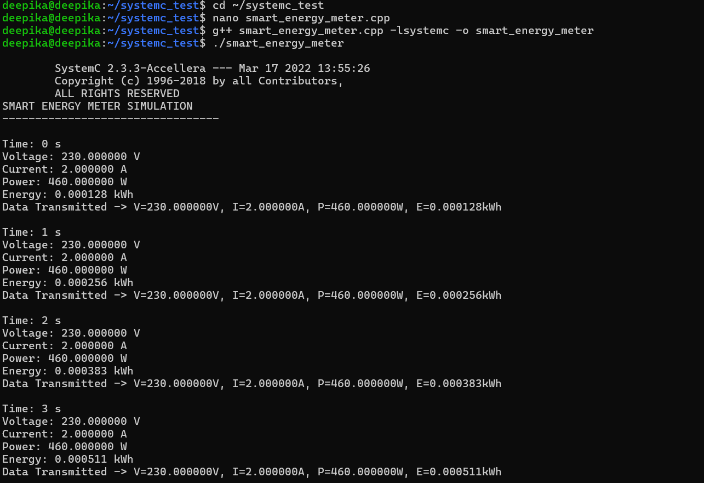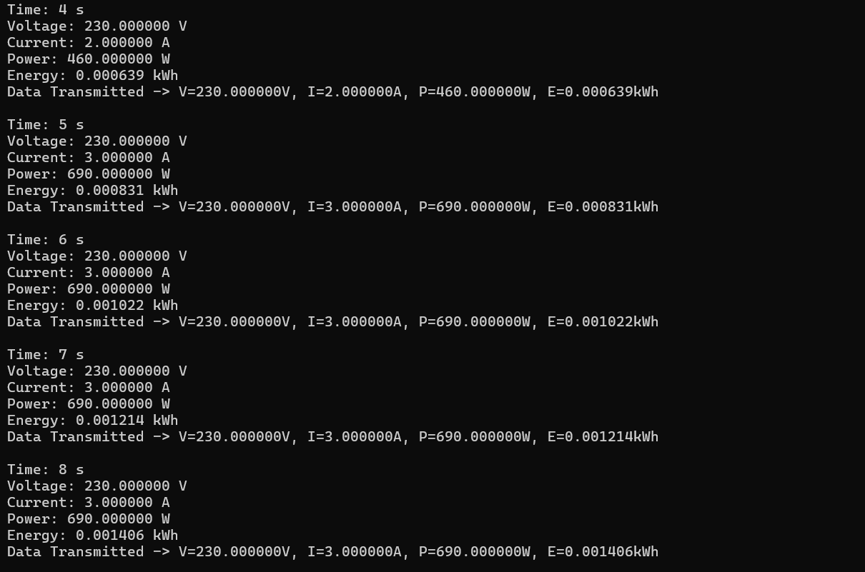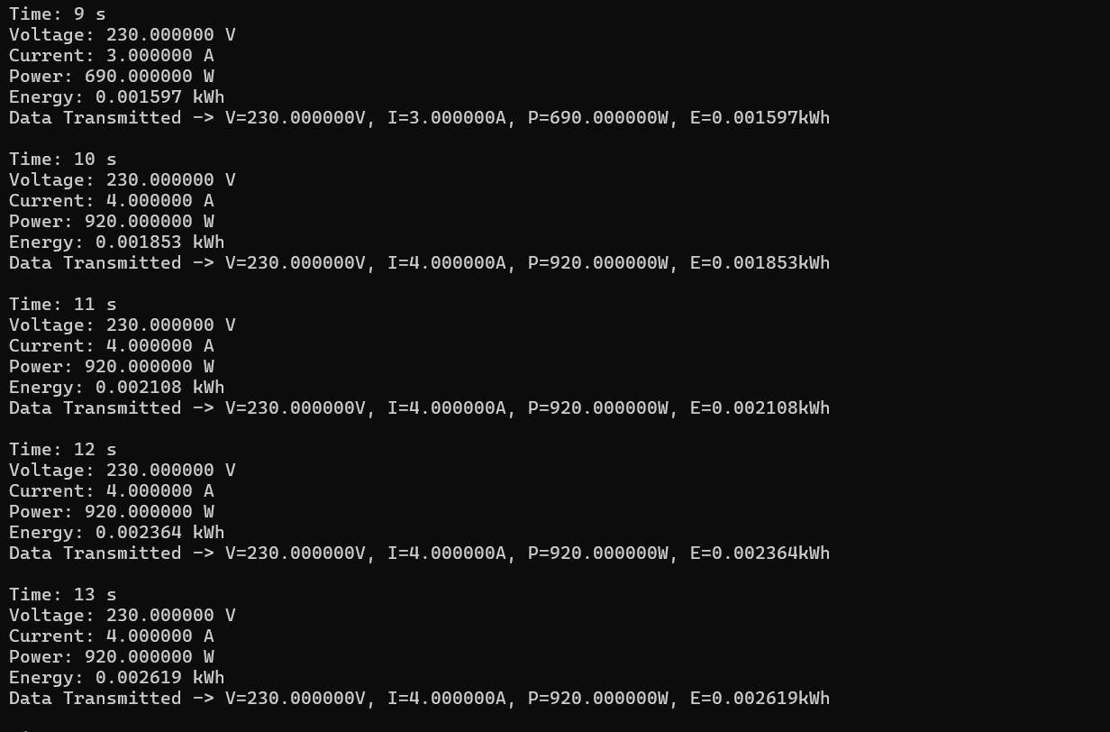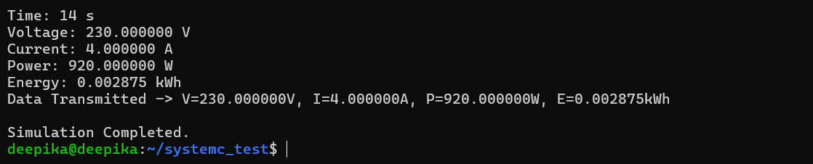
8. Interpretation of Results
The SystemC simulation demonstrates the basic working principle of a smart energy meter. The voltage is maintained at approximately 230 V, while the current is changed during the simulation to represent different electrical loads.
When the current is 2 A:
Power = 230 × 2 = 460 W
When the current increases to 3 A:
Power = 230 × 3 = 690 W
When the current increases to 4 A:
Power = 230 × 4 = 920 W
Therefore, the simulation clearly shows that an increase in load current results in an increase in electrical power consumption.
The accumulated energy value also continuously increases with time because the connected load continues consuming electrical energy.
The statement:
Data Transmitted ->
represents the communication section of the smart meter. In an actual embedded system, this function could be implemented using technologies such as UART, Wi-Fi, GSM, LoRa or another communication interface.
9. Result
The Smart Energy Meter was successfully modeled using SystemC. The simulation calculated voltage, current, instantaneous power and cumulative energy consumption. The calculated meter readings were also successfully represented as transmitted data.
The simulation confirmed that:
- Power increases when load current increases.
- Energy consumption accumulates with operating time.
- Meter readings can be periodically transmitted to a remote monitoring system.
- SystemC can be used to verify the functional behaviour before implementing the design on actual embedded hardware.
10. Justification
SystemC is suitable for this simulation because it allows the hardware behaviour, timing and communication between different modules to be represented before physical implementation.
The proposed smart energy meter is useful because automatic data transmission reduces the requirement for manual meter readings and enables continuous monitoring of electricity usage.
11. Conclusion
The simulation demonstrates a simple smart energy-metering system capable of monitoring electrical consumption and transmitting the measured information. The model can later be extended by adding tariff calculation, overload detection, abnormal energy-consumption alerts, IoT cloud connectivity and automatic billing.

